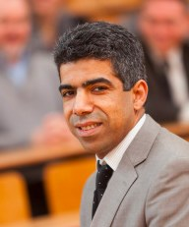

Khalil El Khamlichi Drissireceived the Diploma Engineer, M. Sc., and PhD degrees in Electrical Engineering from Ecole Centrale de Lille and the University of Lille, in 1987 and 1990 respectively. He received the Habilitation in electronics, the highest qualification in France; at the Doctoral School “Sciences Pour l’Ingénieur” of Blaise Pascal University, in 2001. Pr. Khalil EL KHAMLICHI DRISSI became Vice President of Research Valorisation, UBP chancellor board in April 2012. Currently, he is Full Professor at the Department of Electrical Engineering where he was the dean in the period from 2007 to 2011. He is also senior researcher at Institute Pascal Laboratory and his research interests include EMC in Power Electronics and Power Systems, in particular; numerical modeling, EMI reduction and converter control. He authored or coauthored more than 200 scientific papers published in peer-review journals and presented at international conferences. Pr. El Khamlichi Drissi is a member of IEEE and EEA and has been chairperson and member of scientific committees at international conferences. He is project leader and responsible for several international projects related to EMC (FP7 Marie Curie, Integrafm, Cedre, etc…) and a partner within the Brain City Research Institute. He currently has an on-going collaboration with different companies (IFP, EDF, France Telecom and Landis+Gyr).